Section 2.10 Definitions
Height: Building. The vertical distance measured from the finished grade at the center of the front of the building to:
- the highest point of the roof for a flat roof,
- the deck line of a mansard roof, or
- the midpoint elevation between eaves and ridge for a gable, hip, or gambrel roof.
- a line one-quarter of overall height as measured down from top of ridge of roof for “A” frame structures.
For the purpose of building height measurement, the front of a structure is the side facing the front lot line.
BUILDING HEIGHT MEASUREMENT

Lot: A parcel of land occupied, or intended to be occupied, by a main building or a group of such buildings together with accessory buildings, or utilized for the principal use and uses accessory thereto, together with such yards and open spaces as are required under the provisions of this Ordinance. A lot may not be specifically designated as such on public records.

- Lot of Record. A lot that is part of a platted subdivision shown on a map thereof that has been recorded in the office of the Register of Deeds of Washtenaw County; a lot described by metes, and bounds, the description of which has been recorded in said office; or a lot that is a result of a division that can be documented, such as long-term lease, or tax description.
- Lot, Zoning: A single tract of land, which, at the time of filing for a building permit or for a site plan approval, is designated by its owner or developer as a tract to be used, developed, or built upon as a unit, under single ownership or control.
For the purpose of this ordinance, a zoning lot, also referred to as ‘lot’, shall satisfy this Ordinance with respect to area, size, dimensions, setbacks and frontage as required in the district in which the zoning lot is located. A zoning lot, therefore, may not coincide with a lot of record as filed with the County Register of Deeds, but may include one or more lots of record. A zoning lot line shall serve as a lot line for the purposes of establishing building setbacks within the respective zoning districts.

Lot Types
- Corner Lot. A lot located at the intersection of two or more streets. A lot abutting a curved street shall be considered a corner lot if straight lines drawn from the foremost points of the side lot lines to the fore-most point of the lot meet at an interior angle of less than one hundred thirty-five (135º) degrees.
- Interior Lot. A lot other than a corner lot, with only one (1) frontage on a street.
LOT TYPES CORNER LOT TYPES
- Through Lot. A lot other than a corner lot with frontage on more than one (1) street.
Lot Area. (Amended April 21, 2015) The total horizontal area within the lot lines. The lot area shall not include that part of the lot within the right-of-way or easement when a front, rear or side lot line lies in part or in whole in a public right-of-way or private road easement.

Lot Lines. A boundary of a lot separating it from an abutting lot, or the dividing line between lots, pieces or parcels of land or roads.

- Front Lot Line. In the case of a lot not located on a corner, the line separating said lot from the street or right-of-way or access easement. In the case of a corner lot or double frontage lot the “Front Lot Line” shall be that line that abuts the street which serves as primary access to the property.
- Rear Lot Line. Ordinarily, that lot line that is opposite and most distant from the “front lot line”. In the case of existing lots that are pointed at the rear, the “rear lot line” shall be an imaginary line parallel to the “front lot line”, not less than ten (10') feet in length, lying farthest from the “front lot line” and wholly within the lot.
- Side Lot Line. Any lot line other than a front or rear lot lines. A side lot line separating a lot from a street is a side street lot line. A side lot line separating a lot from another lot or lots is an interior side lot line.
Lot Measurements
CUL-DE-SAC LOT
TYPICAL LOT
- Depth. The horizontal distance between the front street line and rear lot line, measured along the median between the side lot lines.
- Width. The straight-line distance between the side lot lines measured at the two (2) points where the minimum front yard setback line intersects the side lot line.

For lots located on a turning circle of a cul-de-sac street, lot width is calculated along an imaginary line that is parallel to ROW line where the minimum lot width is achieved. The lot frontage shall not be less than twenty (20') feet along the cul-de-sac.

Right-of-Way (ROW). A street, alley, or other thoroughfare or easement permanently established for passage of persons, vehicles, or the location of utilities. The right-of-way is delineated by legally established lines or boundaries.

Right-of-Way Line. A right-of-way of a public street or an easement line of a private road. In the case of section line roads, the street line shall be a line thirty-three (33') feet from and parallel to the section line unless an easement or right-of-way of different width is held by the County Road Commission or is otherwise recorded. A right-of-way is also referred to as street line.

Setback. (Amended April 21, 2015) The minimum distance between the lot line and the principal and accessory buildings, as required by the Ordinance. The area within the setback may be used for fences; subterranean installments such as sewers, septic tanks, and drain fields; and trees and shrubs; and parking in residential districts as may be permitted by the Ordinance.
(1) Front. (Amended April 21, 2015) Minimum unoccupied distance, extending the full lot width, between the principal building and the front lot line. For lots located on a turning circle of a cul-de-sac street, minimum setback shall be calculated from the imaginary line that is parallel to ROW line where the minimum lot width is achieved. See Lot Width definition for figure.
(2) Rear. (Amended April 21, 2015) The minimum required unoccupied distance, extending the full lot width, between the principal and accessory buildings and the lot line opposite the front lot line.
(3) Side. (Amended April 21, 2015) The minimum required unoccupied distance, extending from the front setback to the rear setback, between the principal and accessory buildings and the side lot line.

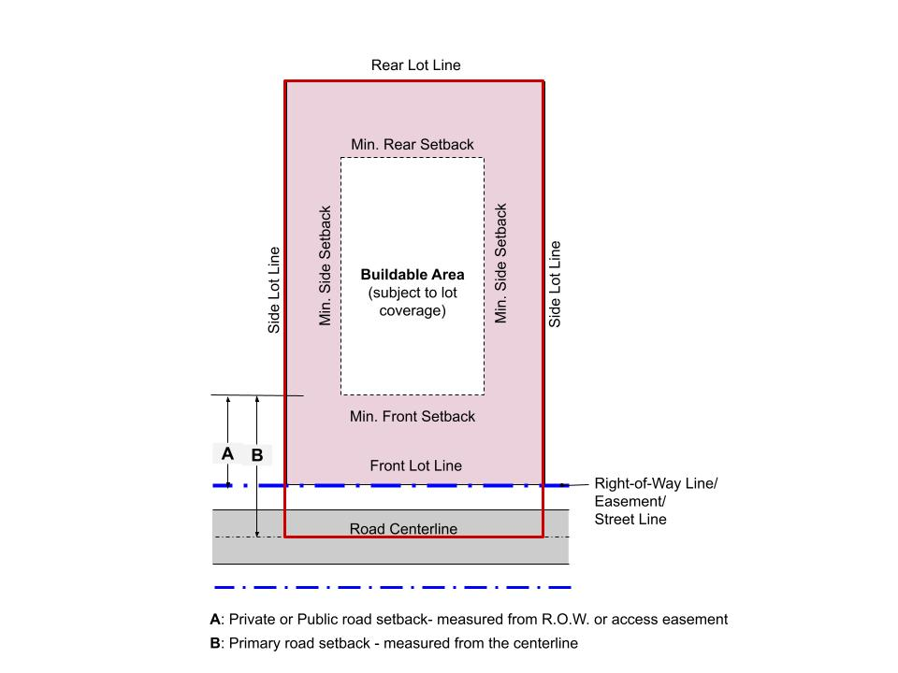
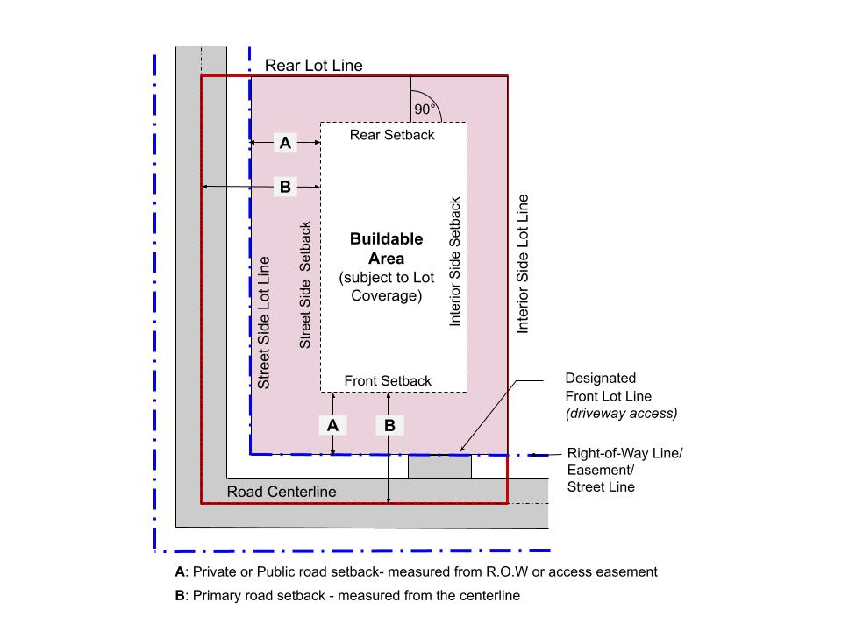
EXISTING NON-CONFORMING TRIANGLE LOTS
TYPICAL LOT CORNER LOT
Yards: An open space, on the same lot with a principal building, unoccupied and unobstructed from the ground upward by a building or structure, except as otherwise permitted in this Ordinance. The following words, terms, and phrases related to yards shall have the following meanings:
- Front Yard: The open space between the front lot line and the nearest point of the principal building, extending the full width of the lot. There shall be a front yard on each street side of a lot, including corner lots and through lots.
- Rear Yard: The open space between the rear lot line and the nearest point of the principal building, extending the full width of the lot.
- Side Yard: The open space between the side lot line and the nearest point of the principal building, extending from the front yard to the rear yard.
- Non-required Yard: The open space between the required setback and the principal building. It corresponds to the additional open space between the required yard and the principal building
- Required Yard: The open space between the lot line and the required setback. The required yard corresponds to the required setbacks for the district.
Lot Frontage. The front of a lot shall be construed to be the portion nearest and abutting the public road or an approved private road. For the purpose of determining yard requirements on corner lots and through lots, all sides of a lot adjacent to streets shall be considered frontage and yards shall be provided as indicated under “Yards” in this Section.
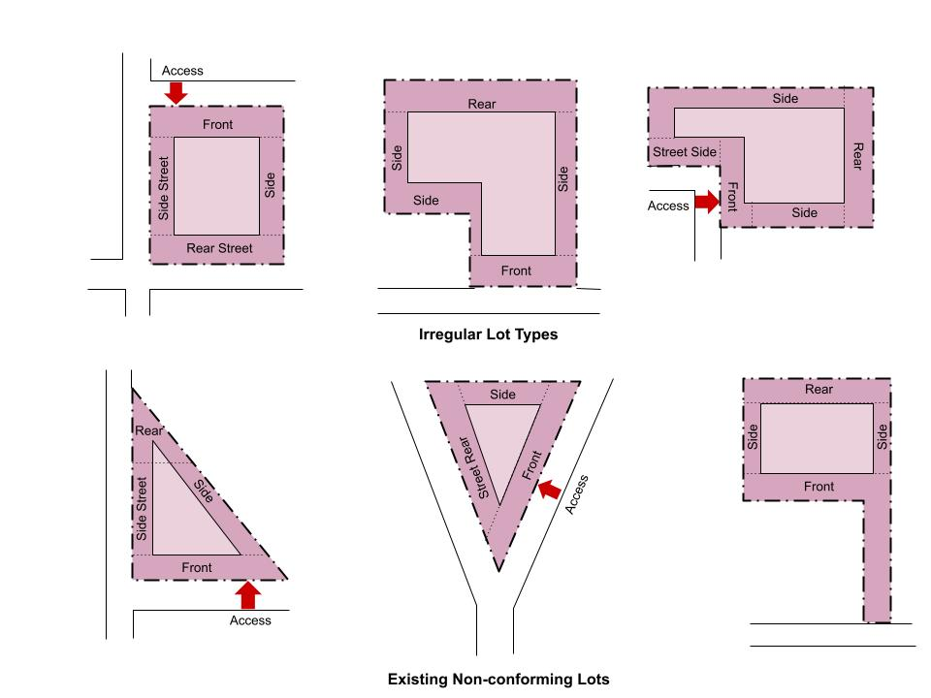
Sec.13.80. Lot Area Requirements
IRREGULAR LOT TYPES – YARD DETERMINATION EXAMPLES

A. to D. No change
E. Lots, Yards and Frontage.
  - Yards shall be provided as required in each zoning district. Additional yards shall be provided as required by Section 13.130 (Setbacks on Primary Roads) of this Ordinance. (Amended March 21, 2017)
- All lots or parcels shall have frontage upon a public street or a Township approved private road meeting the requirements of Webster Township Private Road Ordinance.
- (Amended April 21, 2015) For the purposes of computing minimum lot size within a site condominium or a subdivision, the individual lot area shall not include required transition strips stormwater management facilities or any such spaces that are under common ownership.
- No lot or parcel shall be created that is greater than four (4) times deeper/longer in length/depth than its width.
- The minimum lot width requirement in each district shall be maintained across the entire length/depth of the lot, except as otherwise provided for cul-de-sac.
- No part of a lot, yard, common element or other open space, or an off-street parking or loading space required by or connected with any use, building, or structure for the purpose of complying with this Ordinance, shall be included in the lot, yard, open space, off-street parking or loading space required for any other use, building or structure.
- Yards shall be measured from the exterior faces of a structure to lots lines. Roof overhangs and cornices that project one (1') foot or less from the exterior face shall not be included in the yard measurements. All required yards shall be located parallel and adjacent to property lines, or to transition strips where required, unless otherwise specified.
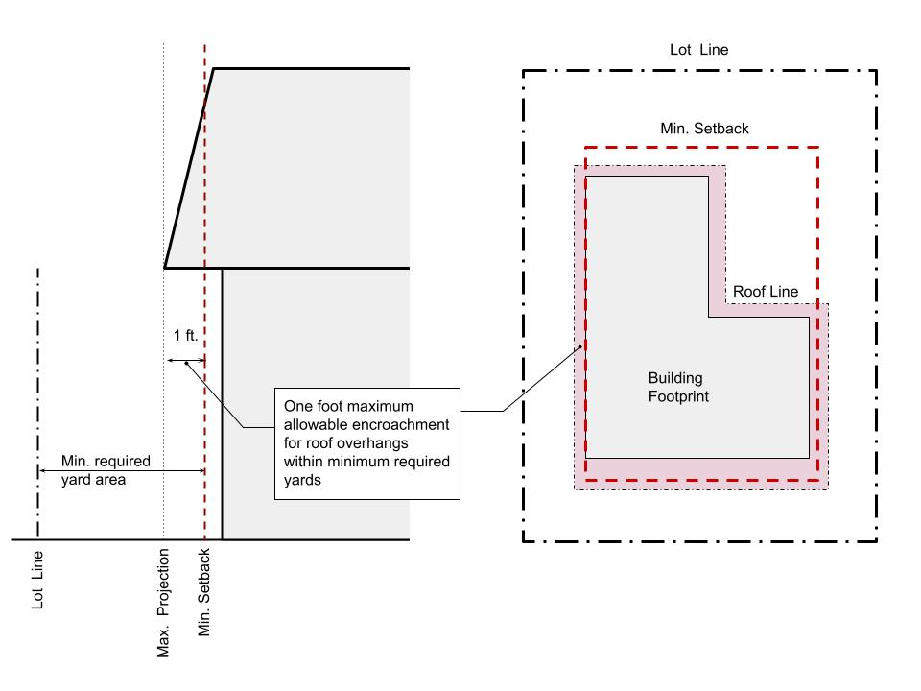
ALLOWABLE ROOF PROJECTIONS INTO REQUIRED YARD

F. Height Regulations. Height regulations shall apply uniformly in each zoning district to every building and structure except that the following structures and appurtenances shall be exempt from the height regulations: spires, belfries, and domes not used for human occupancy; chimneys, ventilators; skylights; water lines and related structures; utility poles and lines; radio, and television broadcasting and receiving antennae, power generating windmills; silos; parapets; and other necessary mechanical appurtenances; provided their location or height shall conform where applicable to the requirements of any other public authorities or agencies having jurisdiction.

